Most of our research and asset-gathering tasks have begun, and we’ve started to develop our first level. Out of 549 total effort points, we have fully completed tasks adding up to 9 effort points and have made significant progress on tasks that account for another 202 effort points. In total, we estimate that we have completed 82/549 of the effort points that exist in our current goals documentation.

As mentioned above, we have begun to develop our first level, and it is possible to walk around the level in first person, using a standard first-person shooter style of keyboard-and-mouse navigation.

From above, the first level’s map looks like this:

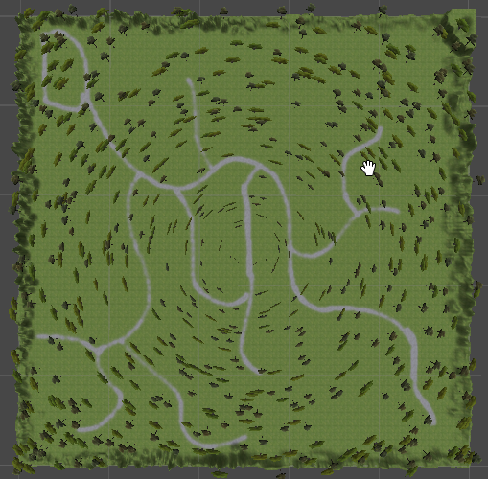

The trees are not actually placed in a concentric pattern. Unity displays them this way when zoomed out. Zoomed in further:

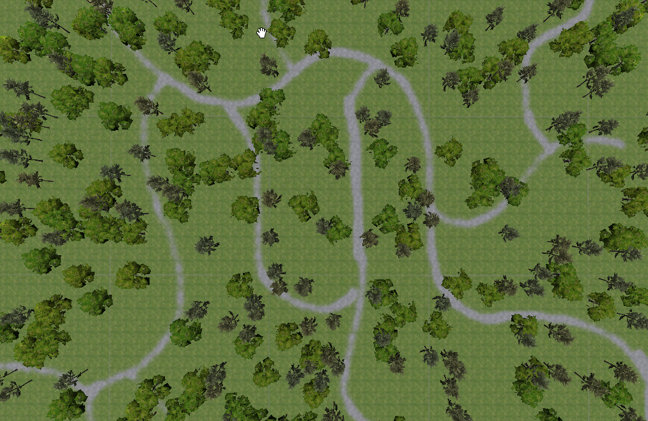

In first person, the level looks like this:

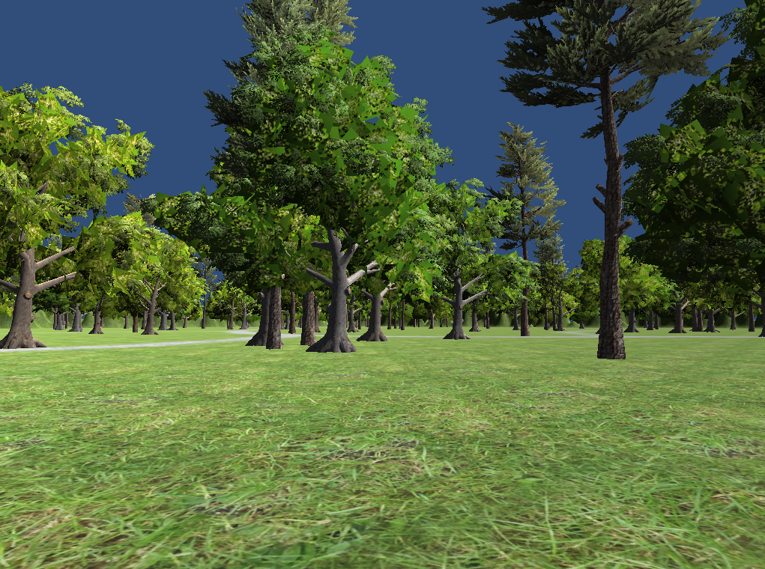

The game also includes a spawning feature which initially spawns four boxes. When the player navigates over a box, that box vanishes, and a new box respawns in a separate location, with a maximum of four boxes present at any time.

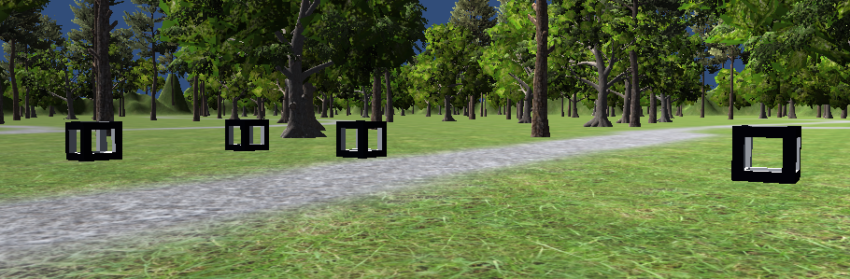

We will utilize this feature for item spawning and for the spawning of enemy characters.

To experience the game so far (and to interact with the spawning feature), you can navigate to <http://gamebucket.io/game/61c87710-089d-4b19-8127-4140979d47ad>. Performance is not perfect in the browser window, as this is being designed as a desktop game, but the game loads well enough in the browser to allow you to see how it looks.

Over the next week, we plan to:

* Add new features to the player character, including weapons and a health meter.
* Add larger landmarks to the first level map.
* Add enemy characters with simple AI to the first level map.
* Add a basic game menu system.
* Continue to research AI.
* Continue to collect assets for the game.
* Research Unit Testing in Unity so that we can begin to implement this across all of our code.